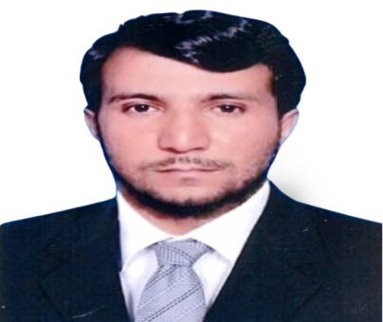
  - CAREER OBJECTIVE:

Whatsapp: +92 3059148772
Email: abdurrahmaniiu1@gmail.com

Abdur Rahman

Personal Details:
Father Name: Hayazeer Khan
Address: Lower Dir KPK,
Pakistan
Passport Details:
Passport NO: PU 9159381
Date of Issue: 7th December, 2018
Date of Expiry: 7th December, 2023
Languages Known:
- English
- Arabic
- Urdu
- Punjabi
- Pashto
Professional Skills:
- Teaching Certificate
- English Language proficiency Certificate
- LLB (hons) Students Research Supervisor
- Assistant Exam Coordinator.
- Member of Examination Grievous Committee,
- Classroom & time management.
- Work as an administrator.
- Students Supervisor of LLB in UoSwabi and SBBU Sheringal.
Computer Skills
- MS Office, power point, Internet etc.
- Use of Google, Fullfreepdf.com, Google Scholar, ZOOM

P
In my work, I am always diligent, conscientious, and I will never miss a deadline. Whilst carrying out my duties I will always be competent & proficient. I am always solution oriented whilst dealing with challenges and problems. I can share ideas and interact with children to encourage creativity and higher-order thinking in a way that increases performance.
EDUCATIONAL QUALIFICATION:
Master of Law (LLM MFL) | International Islamic University, Islamabad, Pakistan—2019
Bachelor of Law (LLB (hons) Shariah and Law | International Islamic University, Islamabad, Pakistan-- 2014
B.A General | International Islamic University, Islamabad, Pakistan-- 2014
Arabic Language Certificates | International Islamic University, Islamabad, Pakistan-- 2009 to 2010
Higher Secondary School Certificate Inter Science | Board of Intermediate & Secondary Education, Malakand-- 2008 to 2009
Secondary School Certificate Science Group | Board of Intermediate & secondary Education, Malakand -- 2006 to 2007
WORK EXPERIENCE
- Lecturer in University of SBBU Sheringal, Dir Upper KPK, from 2nd December 2022 continues.
- Worked as an Assistant Operation manager in APL Global Logistics LLC UAE from August to November, 2022.
- Lecturer in University of Swabi, (from 1st November 2021 to July 15, 2022).
- Lecturer in Muslim Law collage, Swat Pakistan (From 1st October 2020 to 30th October 2021).
- Visiting Lecturer in University of Swat, Pakistan (September 2017 to July 2020)
- Visiting Lecturer in International Islamic University Islamabad, Pakistan (Spring Semester 2016 and fall 2017).
- Internship in Federal Ombudsman Secretariat Islamabad Pakistan (from 1st April 2016 to 5th May, 2017).
- Worked as a practicing Lawyer in DBA Rawalipind from 1st January 2015 to 30th March 2016.
CERTIFICATION / MEMBERSHIP
- Member District Bar Association, Rawalpindi, Pakistan
- Legal consultant in Family Law, property Laws, Administration Law
- Certificate 26 training Course for IIUI students, Dawah Academy Islamabad
- Executive Member of Law Students Counsel
- Certificate of one year Internship in Federal Ombudsman of Pakistan.
Declaration:
I hereby certify that the above information are true and correct according to the best of my knowledge & my experience.

